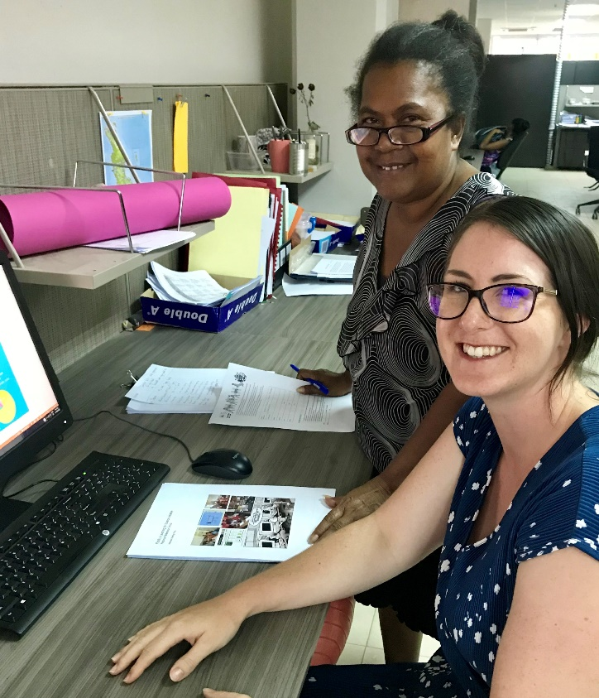

Jessica Wright
I am an ICT Curriculum Development Mentor to the Ministry of Education and Human Resource Development as part of the Australian Volunteers Program.
I hope to use my experiences as a High School Languages and History teacher in Port Macquarie, Australia to support the development of an inclusive, student-centred curriculum that harnesses the great potential of technology to engage Solomon Islands students in the learning process.
The challenge of resourcing teachers and their students with quality teaching and learning materials is significant in a country comprised of 922 islands (over 300 of them inhabited). However, the creative use of ICT provides a powerful opportunity to rise to this challenge, particularly in light of recent news about the construction of the subsea cable which will have a really positive impact. I’m really excited to be supporting the Ministry of Education in considering and planning for how ICT might be used to assist Solomon Islands teachers to equip their students with the skills that they need to be able to thrive into the 21st Century and work towards building a brighter Solomon Islands together.
During my year here I’ll be involved in the writing of an ICT in Education Master Plan, will work with the Curriculum Development Division to source and curate curriculum-aligned materials to be distributed in both online and offline modes and provide support in the area of teacher training, building the capacity of teachers to effectively use ICT-enhanced teaching and learning strategies.
I’m also really looking forward to putting my snorkel set to good use exploring the gorgeous natural beauty that the Solomon Islands has to offer.

